PHY605: Term Paper (III) 2 CH

Nature of the course: Research/Presentation Full Marks: 50 Pass Marks: 30

Course Description:
This course develops the skill of research work in Physics.

Objectives:
The course will give an exposure to the students regarding the problem identification in the
various areas of research work in Physics by performing book, literature review and finally
deliver a presentation followed by VIVA examination.

Term Paper Guidelines
1) A student can do project work only if a physics faculty of the department agrees to guide his/her Term Paper. The criteria for the ‘Term Paper Guidance’ will be developed by the Central Department Research Committee (CDRC).

2) Term Paper will be carried out in groups of either two or three students under a project. They should work as a team for their objectives. This course will be offered in the third semester to the students who already enrolled for the dissertation, and the rest students with two elective papers will do it in the fourth semester.

3) The nature of Term Paper work can be field oriented, theoretical, computational, observational and experimental. Whatever the nature of the work, students should critically review literature of the area of interest and identify the problem specifically. It is expected that the problem can be addressed through a method.

4) Students should prepare a two-page proposal (title with a brief description) and submit it to the department within 2 months of the beginning of third semester. Supervisor should sign the proposal.

5) The Term Paper report should be submitted by students separately. The format of the Term Paper report will be decided by the Central Department Research Committee (CDRC). There will be a final presentation by the group followed by VIVA examination. The final VIVA examination will be held within one months of third semester practical examination. The Dean Office will appoint the external examiner of final VIVA examination. The evaluation committee for the final VIVA examination consist 4 members
- HoD or program coordinator,
supervisor,
external and
internal examiner.

6) There will be additional fee for the Term Paper. It should be paid by the student during submission. The remuneration for the evaluation committee will be the same as the M.Sc. Project Work decided by the IoST, TU in the year 2072.

Text / Reference Books:
All related literatures, masters’ dissertation and Ph.D. thesis of various areas of Physics can be reading/performing material for term paper.

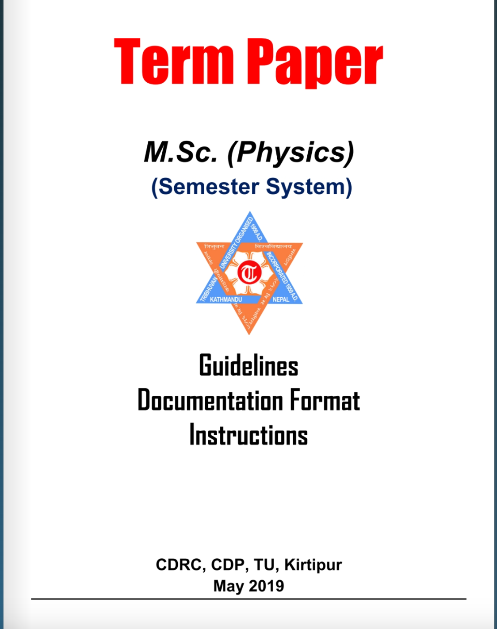

Proposal for Term Paper (Cover Page)
TITLE OF YOUR TERM PAPER PROPOSAL
(All capital, Bold, size 28)

A Term Paper Proposal
(Bold, size 24)

Submitted to Department of Physics
Prithvi Narayan Campus, Pokhara
Tribhuvan University, Nepal
(Normal, size 18)



By
(Your Name)
Examination Roll Number
Email:
May, 2025
(Bold, size 18)

OUTLINES (all the font and styles should be as per report format)
- INTRODUCTION
A brief introduction of the topic with the relevant literature review
- OBJECTIVES
- METHODOLOGY
The process, how will you achieve the objectives
- EXPECTED OUTCOMES
- REFERENCES

Reference style

5.1: Text Citation: References in text, should be in the form [1] or ………recent
experiments [5,6]. The names of all authors of cited papers should normally be given in the references except when the number of authors is very large (say, more than 10).

5.2: The reference style should be as follows:
[cited number] Authors (first name in abbreviation & full family name), Full title of the article (italic), Journal name (standard abbreviated form), volume number (boldface), Issue Number (if needed), page number, and year (in bracket)

[cited number] Authors (first name in abbreviation & full family name), book title (in italic), editor(s) (if required), publisher, year of publication (in bracket)

[cited number] Authors (first name in abbreviation & family name), title of the research work (Ph.D. or M.Sc. or technical/scientific report – in italic), publisher (University/Institute or any Research Agency), and year of publication (in bracket)

Examples:
[1] C. Oostenbrink, T. A. Soares, N. F. Van der Vegt, and W. F. Van Gunsteren, Validation of the 53a6 gromos force field, Eur. Biophys. J., 34, 4, 273-284, (2005).
[2] H. J. C. Berendsen, J. R. Grigera, and T. P. Straatsma, The missing term in effective pair potentials, J. Phys. Chem., 91, 6269-6271 (1987).
[3] J. M. Smith, Molecular Dynamics, Elsevier, New York (1980).

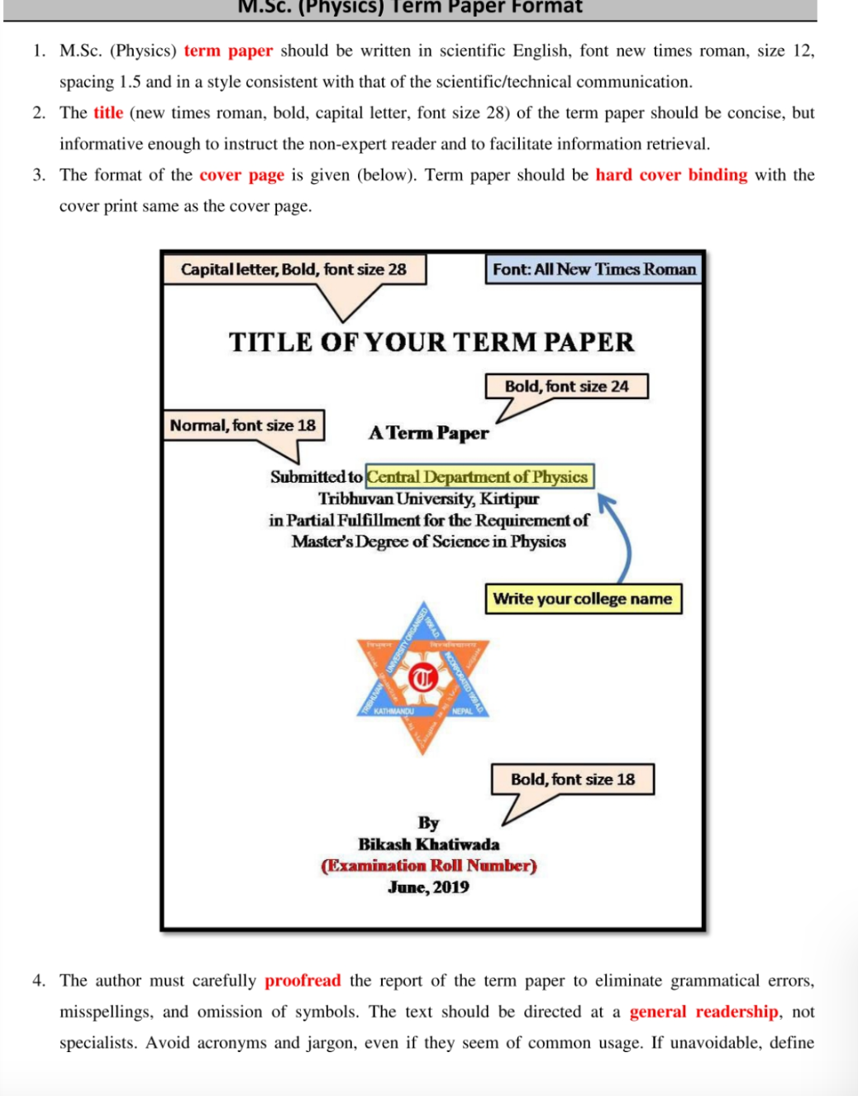

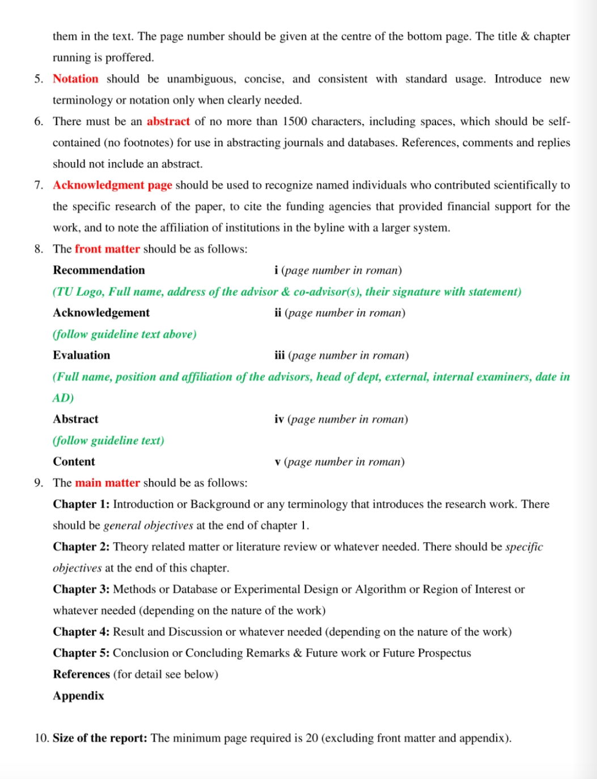
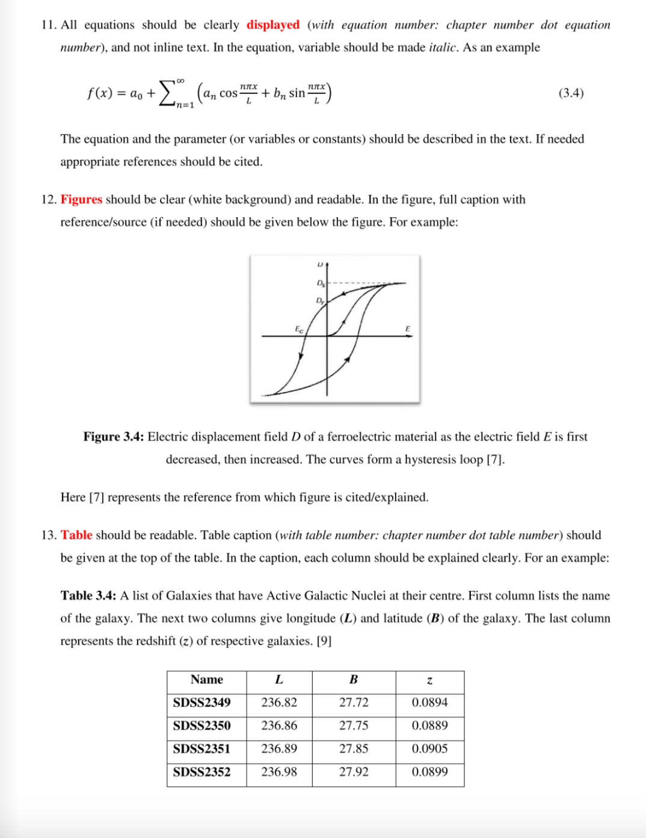
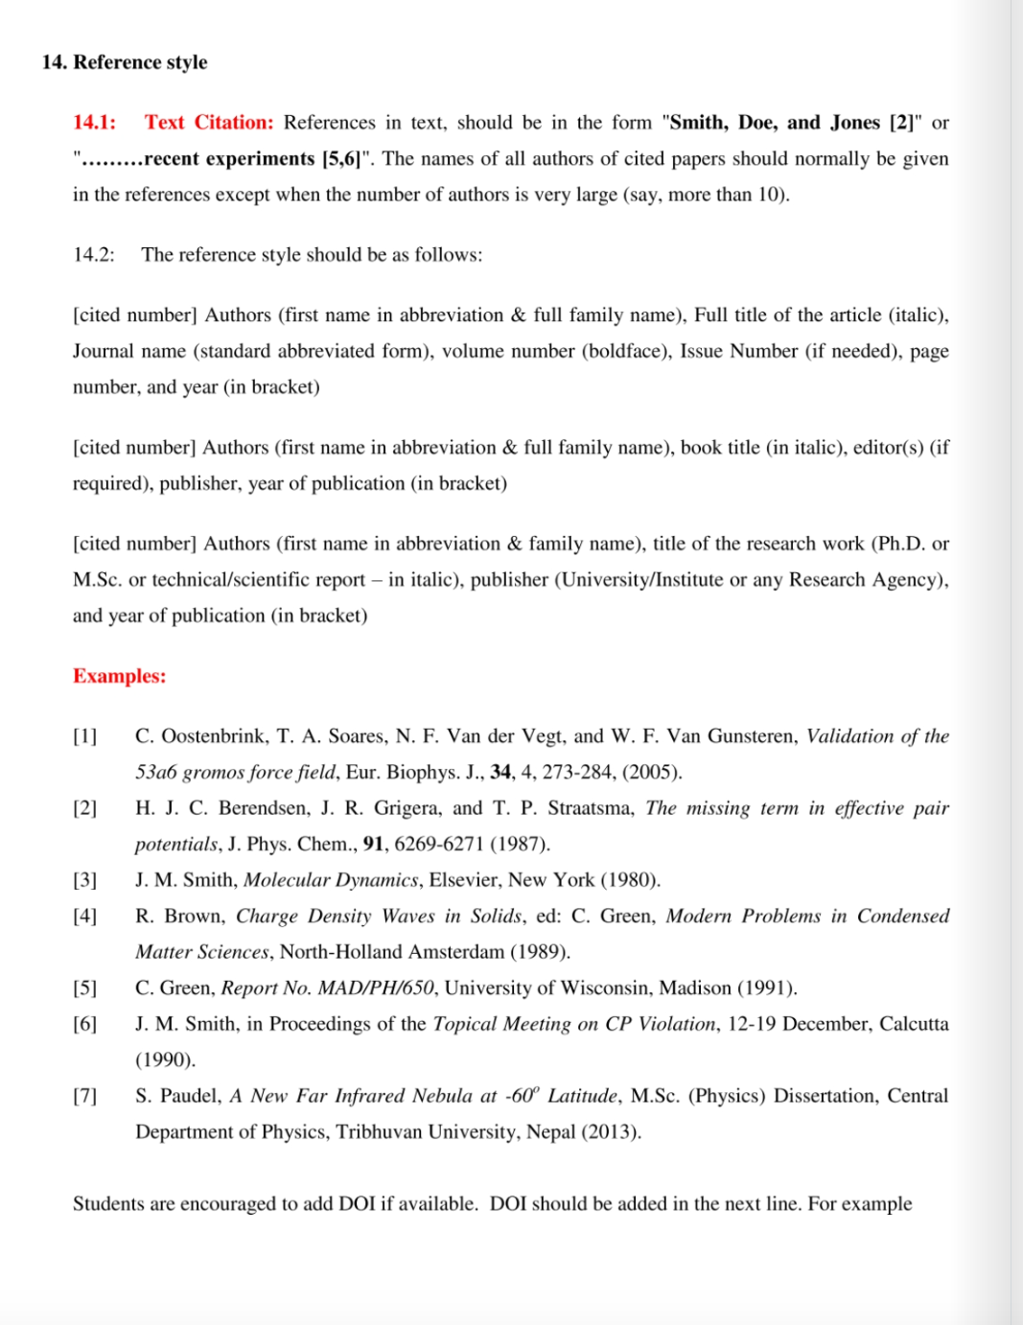
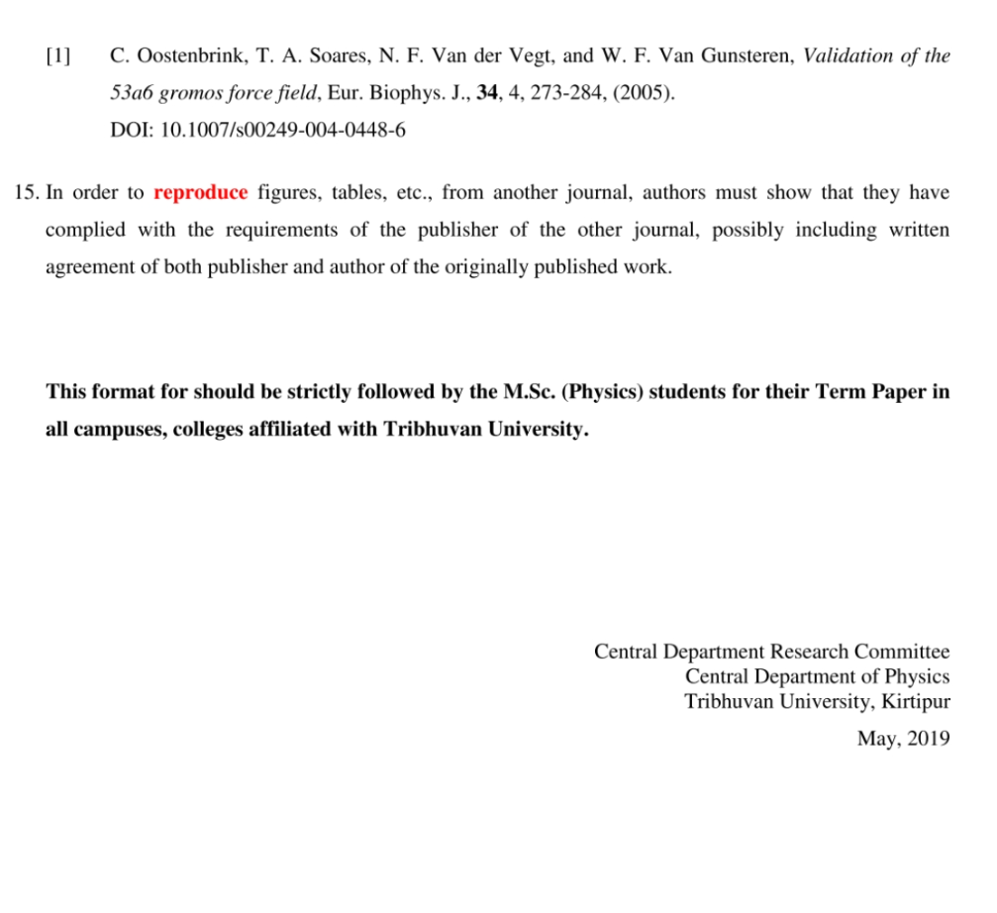

TERM PAPER FORMAT (Cover Page)
All Font: Times new Roman

