Applying for Research/Gratis Visa for Visiting/Exchange Scholars

Definition of visiting/exchange scholar: A student or faculty member or staff affiliated with a partner institution that has Memorandum of Understanding (MoU) or Memorandum of Agreement (MoA) or Letter of Agreement (LoA) or any other form of agreements with Tribhuvan University; working closely with one or more faculty members at Tribhuvan University; and wants to visit Tribhuvan University for a short or long-term stay and a unit (e.g. Department/Campus/Institute/ Faculty) at Tribhuvan University is willing to host him/her.
Process for applying for Research/Gratis Visa: After the prospective scholar gets in touch with relevant faculty members in the hosting unit (Department/ Campus/Institute/Faculty), the unit writes a formal letter to the Centre for International Relations (CIR), Tribhuvan University requesting for facilitating for research/gratis visa as per Template provided in next page. After review and evaluation of the application, if CIR is convinced, CIR writes a letter to Ministry of Education, Science and Technology. In case of Visiting Faculty, the application is further forwarded to other relevant government ministries (e.g., Ministry of Home Affairs; Ministry of Labor, Employment and Social Security, etc.), as required, before sending to the Department of Immigration for further processing. In case of exchange students, Ministry of Education, Science and Technology forwards it to the Department of Immigration directly.
Final decision: Final decision on whether granting or not the research/gratis visa will be made by Department of Immigration as per Rules and Regulation of the country. The Department will then communicate directly to the applicant.

Contact Address:
Centre for International Relations
Office of the Vice Chancellor
Tribhuvan University, Kirtipur, Kathmandu
Tel No: 977-1-4330840 / 4332500
Email: info.cir@tu.edu.np
Website: https://cir.tu.edu.np/

<Letter Head of Hosting Department/Campus/Institute/Faculty>

Ref. No.:
Date: DD-MMM-YYYY

To,
Executive Director,
Centre for International Relations
Tribhuvan University, Nepal

Subject: Request to Facilitate for Research/Teacher (Gratis) Visa

Dear Sir/Madam,
As per the MoU/MoA/LoA signed between Tribhuvan University (Nepal) and ………………………………..(name of institute (country)) on ………….(date of signing), following scholars/professors/students from ……………..(name of institute) are visiting Tribhuvan University. Their personal details are attached along with this letter.
S.N. | Full Name | Passport No. | Country | Designation at partner institute | Visa Period
1
2
3
4
5

They will be working with ………………(name of professor responsible for) and engaged in ……………………..(please write down their activities during their stay in Nepal) and will benefit university with ……………..(please write how the university benefit by hosting them).

I would like to request for facilitating for research/gratis visa for those scholars/professors/ teachers/ students.

With Warm Regards,

Signature, Name, Designation, and Stamp

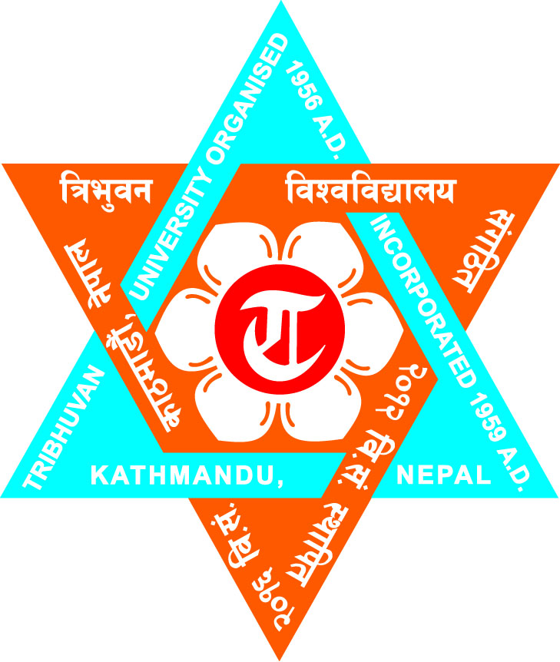
CENTRE FOR INTERNATIONAL RELATIONS
Passport size photo
OFFICE OF THE VICE-CHANCELLOR
Tribhuvan University

PERSONAL DETAILS OF APPLICANT

- Name:
- Date or Birth:
- Address:
  - Permanent:
  - Temporary/Contact (in Nepal):
- Nationality:
- Duration of Stay in Nepal:
- Present Status in Nepal (if applicable):
- The Need of Extension of Visa:
- The Nature/Character of the Aforesaid Person:
- Work Satisfaction so far:
- Passport No:
- Visa Expiry Date:
- Duration of Extension of Visa:
- Details of Dependents:
Name | Relation | Passport Number | Date of Expiry of Current Visa

Recommended by:

<please insert signature, name, designation (Dean/Director, Campus Chief, Head of Department), unit (e.g., Department/Campus/Center/Institute/Faculty)

977-1 -4330840 / 4332500, Email: info.cir@tu.edu.np Website: https://cir.tu.edu.np/ PO Box No: 8212, Kirtipur, Kathmandu, Nepal

